ACORN information sheet

What is ACORN?
Essentially ACORN is a way of finding out who it is God might be call you to make contact with in your community or circle or friends – people who are not part of a church community.

The letters of ACORN spell out the way it works:
ASK – we ask God in prayer to guide us, nudge us, show us who it is we are to speak to
CALL – we listen for the call of God in answer to our prayer
OBEY – we follow God’s leading and take the opportunity to speak with the person
REPORT – we meet with a small group of people to share what has happened
NOTICE – we, collectively, notice what God is doing in and through both us and the others

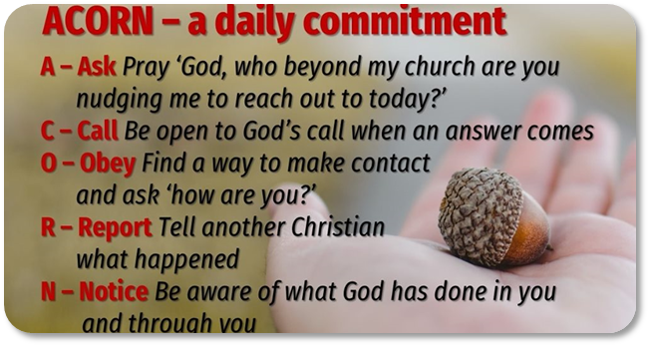

Reasons why ACORN works
These reasons have all come out of reflective experience, among people in three ACORN groups over a six-month period.

8 min Introduction of programme by Dr Michael Harvey:
https://www.youtube.com/watch?v=Lcw16Z_y-k0&feature=youtu.be

5-6 min promo videos from groups:
https://youtu.be/sCKAnwV-xrA
https://www.youtube.com/watch?v=GBG4gTzlreQ

Facebook group:
https://www.facebook.com/groups/933478613810194/

In addition to the videos, there’s a list of more than a dozen reasons including:

- It puts God in charge
- It puts mission first
- Everyone can do it
- No need for resources
- It suits anyone’s lifestyle
- It encourages and builds up
- It deepens our faith
- Jesus gave us the task
- The power of stories
- All are called to be ‘ministers’

Social media

There is a series of images that you can use for posts on your church FB page – please email lwalker@churchofscotland.org.uk for further information.

