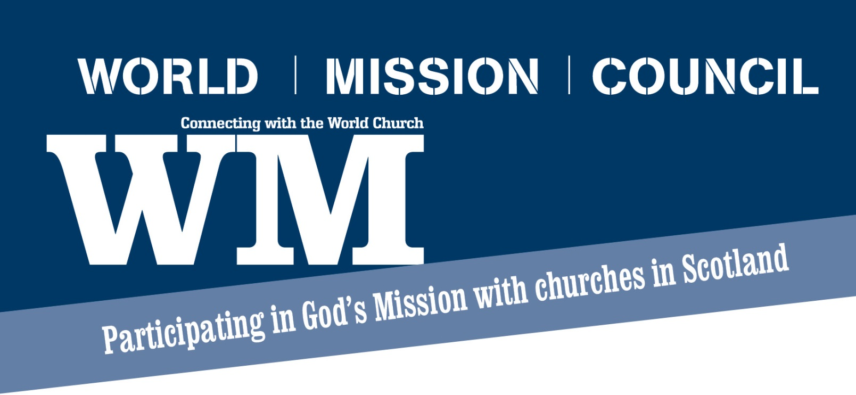 **World Church Representative**

So what am I meant to do? What does this mean for my church?

Where can I get resources? Who can help me?

These are just some of the questions you might be asking yourself!

So what does your role involve?

**Informing** - the minister, Kirk Session and the congregation of the worldwide work of the Church of Scotland.

**Involving** - the congregation in the life of their fellow Christians beyond their own parish and their own denomination.

**Organising** - activities both with the congregation and with other churches, with the assistance of other members of your congregation.

**Liaising** - with their Presbytery's World Mission convener to share information and support work beyond your own church.

**Receiving** - World Mission’s regular magazine WM which provides an insight into the ongoing worldwide work of the Church of Scotland.

**What does it mean for my church?**

We hope that through your information, support and encouragement others in your church will become more involved in the work of the church across the world. That could take many forms be that holding a Souper Sunday, praying for a Mission Partner, developing a twinning with a church in another part of the world, organising a Fairtrade stall or simply taking a more active interest in the work of the worldwide church. Whatever form it takes your congregation will be building new relationships with others in the world church.



**Useful Resources**

**People** - The best and most valuable resource you have are the people you know, the people you meet and the people we can put you in contact with. Share information, share ideas, learn lessons. Make the most of opportunities to meet with others and to learn from them and them from you. And then pass that knowledge onto your congregation.

**WM** - every 6 weeks we will mail you a copy of WM, a magazine that provides valuable stories and information about our partner churches and our Mission partners. Use this resource by sharing sections in your church magazine or ask us to send you more copies so that you can have them available for others. You can order as many as you need for your congregation and they are free! WM is also available on the website. Contact Nicki Skinner to place your order [nskinner@churchofscotland.org.uk](mailto:nskinner@churchofscotland.org.uk)

**Update** - this weekly e-bulletin is emailed out each Wednesday and provides an up to date briefing of what our partner churches are doing. This is a great source of information to share with your congregation every week. You can sign up at any time by contacting [kbradley@churchofscotland.org.uk](mailto:kbradley@churchofscotland.org.uk). Why not use this on your screen in church?

**Facebook** - if you use social media, why not “like” our page and follow us on a regular basis @ Church of Scotland World Mission Council page

**Website** - full of useful information, resources and updates.

[www.churchofscotland.org.uk/serve/mission_worldwide](http://www.churchofscotland.org.uk/serve/mission_worldwide)

**Useful People**

**Carol Finlay** is the Twinning and Local Development Secretary. Carol oversees our work across Scotland. What Carol doesn’t know about our relationships with others across the world possibly isn't worth knowing and if there is something she doesn't know she will know the person who does! [cfinlay@churchofscotland.org.uk](mailto:cfinlay@churchofscotland.org.uk)

**Karen Gillon** is our Local Development Officer. If you have any questions, issues or problems then Karen is your first point of contact. She is there to support you in your role by providing information, advice or by coming out to support you in running meetings or events. [kgillon@churchofscotland.org.uk](mailto:kgillon@churchofscotland.org.uk)

**Katie Bradley** is our Development Officer. Katie edits WM, Update and keeps our website and Facebook page updated. She also writes reports on issues where our partners have an involvement such as Gender Based Violence or Human Trafficking. You use these reports in your church to increase awareness. [kbradley@churchofscotland.org.uk](mailto:kbradley@churchofscotland.org.uk)

**Rebecca McGonigle** is our Twinning Development Officer. She will be able to help you if you want any advice on linking up with a church in another part of the world. We now have over 200 churches twinned with other partner churches and they are all on a journey, sharing faith, knowledge and skills. [rmcgonigle@churchofscotland.org.uk](mailto:rmcgonigle@churchofscotland.org.uk)

**Marjorie Clark and Elena Sarra** are our Church of Scotland HIV Programme coordinators. If you want to know more about what the Programme does or ways in which you can get involved they are the people to contact. [mclark@churchofscotland.org.uk](mailto:mclark@churchofscotland.org.uk) or [esarra@churchofscotland.org.uk](mailto:esarra@churchofscotland.org.uk)

**Nikki Skinner** is our Administrator who is responsible keeping all of our information systems up to date so if your email, telephone number or address change please let Nikki know. [nskinner@churchofscotland.org.uk](mailto:nskinner@churchofscotland.org.uk)

**Audrey Grahame** is our Senior Administrator who looks after our Faithshare Programme. She will be able to help in all the arrangements for visits to or from a Partner Church. [agrahame@churchofscotland.org.uk](mailto:agrahame@churchofscotland.org.uk)

**Getting in touch**

By post: 121 George Street, Edinburgh, EH2 4YN Tel: 0131 225 5722

Email: [world@churchofscotland.org.uk](mailto:world@churchofscotland.org.uk)

Web: [www.churchofscotland.org.uk/serve/mission_worldwide](http://www.churchofscotland.org.uk/serve/mission_worldwide) Facebook: Church of Scotland World Mission