Let us build a house
Presbytery Conveners Challenge 2015-2018

About Nepal

Location | Southern Asia, between India and China
Capital | Kathmandu
Population | 27.8 million (2013)
Religion | 81.3% Hindu; 9% Buddhist; 4.4% Muslim; 3% Kirant; 1.42% Christian; 0.9% other or no religion (2011)
Displaced peoples post 2015 earthquake | 400,000+
Dhading

Dhading is a fertile agricultural district, a three hour drive from Kathmandu. It extends high into the mountains, right up to the Tibetan border. Our partner the United Mission to Nepal (UMN) has been working there since 2005 and now have 10 partners in the area. In the south, along the highway, exposure to HIV and AIDS is high, and discrimination against people living with AIDS is a concern. One of UMN’s partners also works in two remote northern areas, where travel is difficult and services for villagers are scarce.

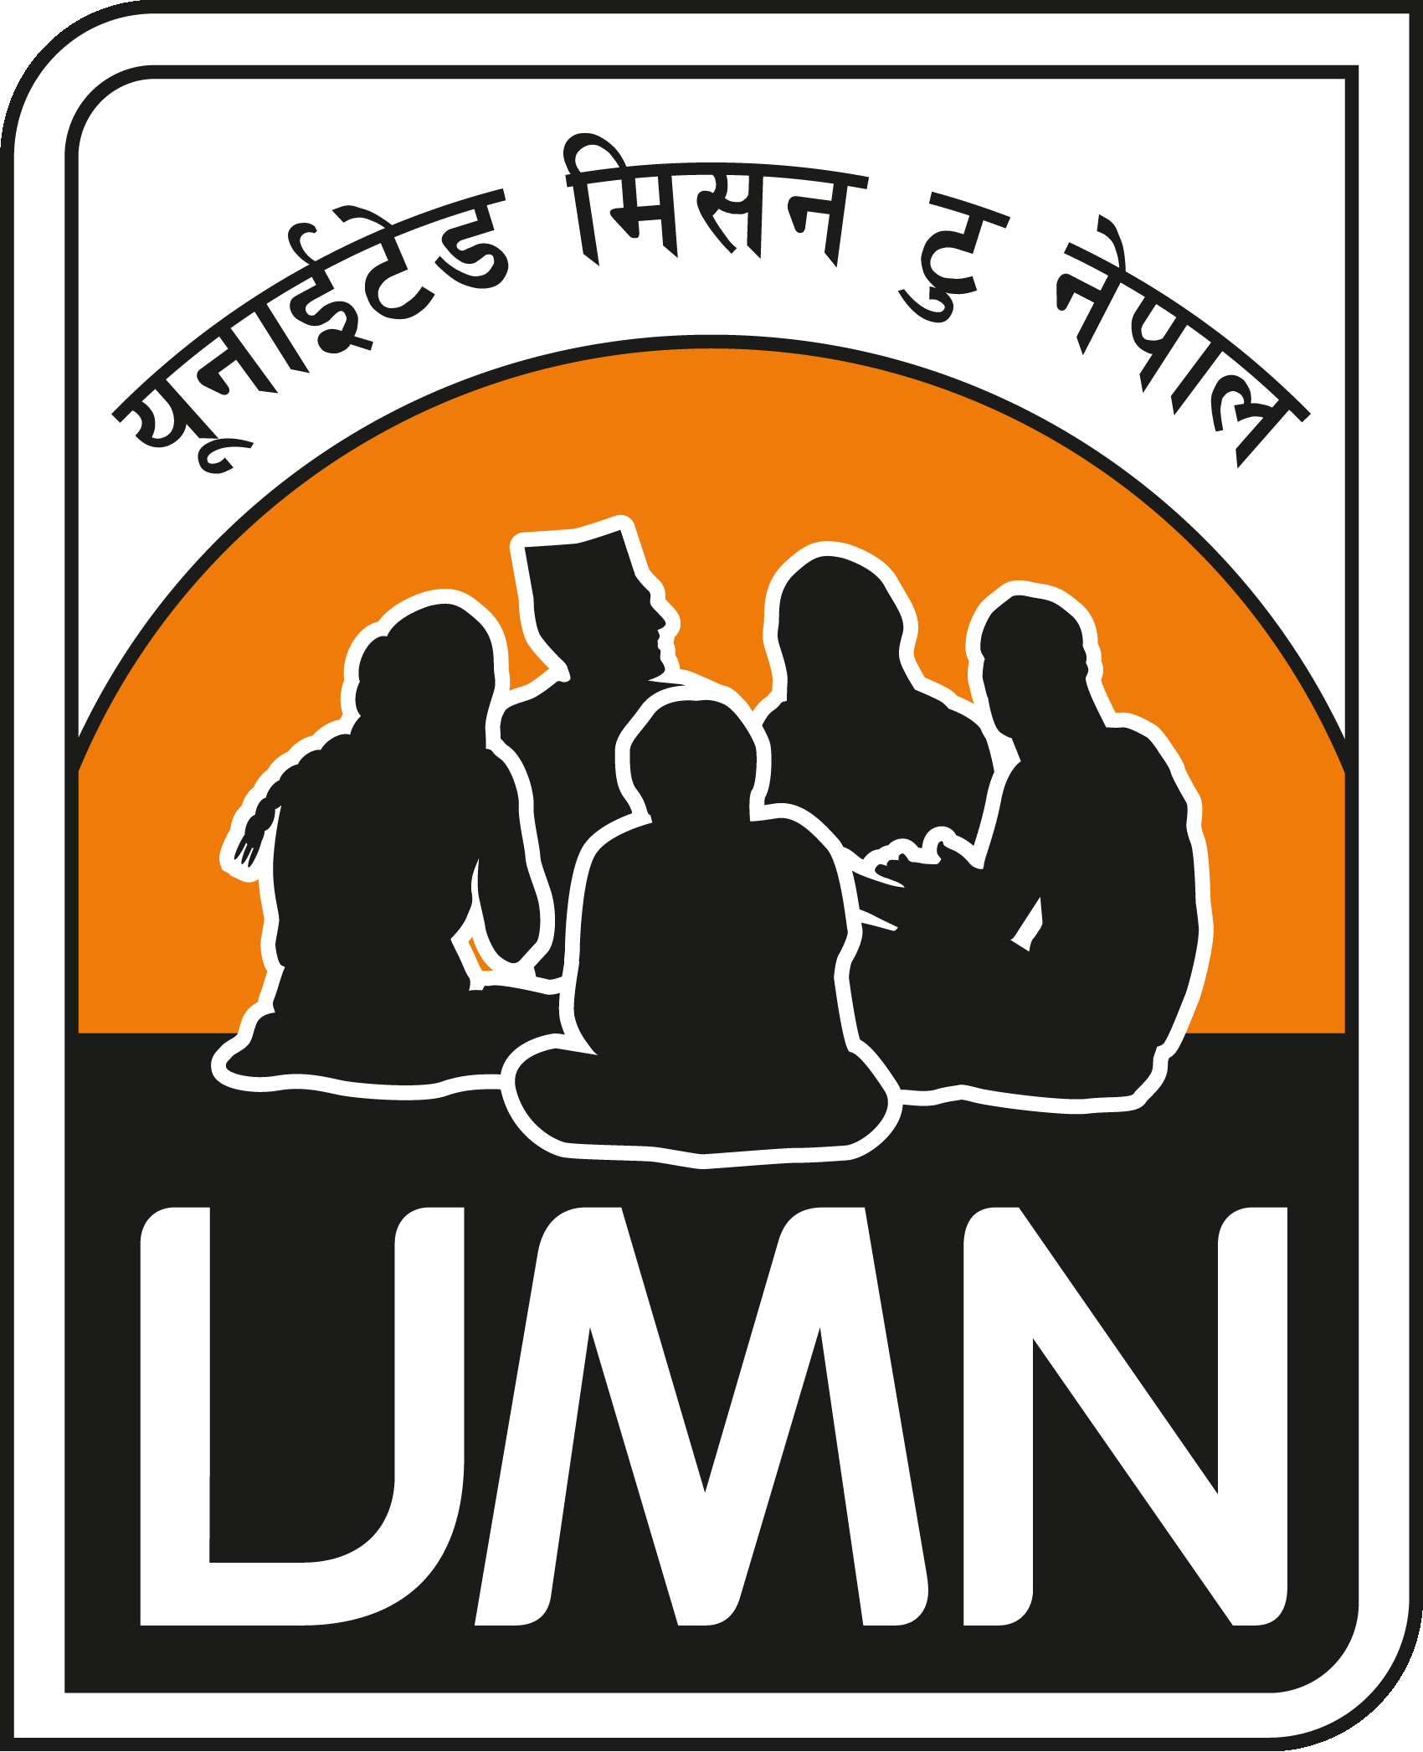
UMN will be very involved in the rehabilitation work in Dhading, one of the most affected districts. They have been working in Dhading for many years, and have strong relationships and capable partners there.
Christians in Nepal

While still representing only a small fraction of the population, Nepal's Christian community, in existence since the early 1950s, is reportedly one of the fastest growing in the world. In the past Nepali Christians faced much persecution, and while this still persists, recent years have brought increased religious freedom for Nepali believers.

Churches in Nepal continue to grow and mature, spreading the Good News and seeking to build Christ-following communities throughout the country. Their commitment and love for God and for others is often an example to churches in the west. Now that Nepal is officially a secular state, churches have been more open and involved in the public sphere. However, many
Christians still face suspicion and discrimination in their families and
communities.

Prayer requests from UMN

Please pray:

- for the many families and communities who have lost homes, livestock, food stores and seed.
- for UMN’s support for Temporary Learning Centres, which will fill the gap left by schools damaged and destroyed
- for health workers being trained in the area of emergency nutrition
- that farmers will be able to plant their crops, that small businesses can be restarted, and that people will be able to support their families
- for work being done to help communities prepare for disasters, especially during the monsoon months
- that churches will be able to rebuild, and reach out to their communities
- for church leaders, for wisdom and discernment
- that people of different religions will be able to work together well

