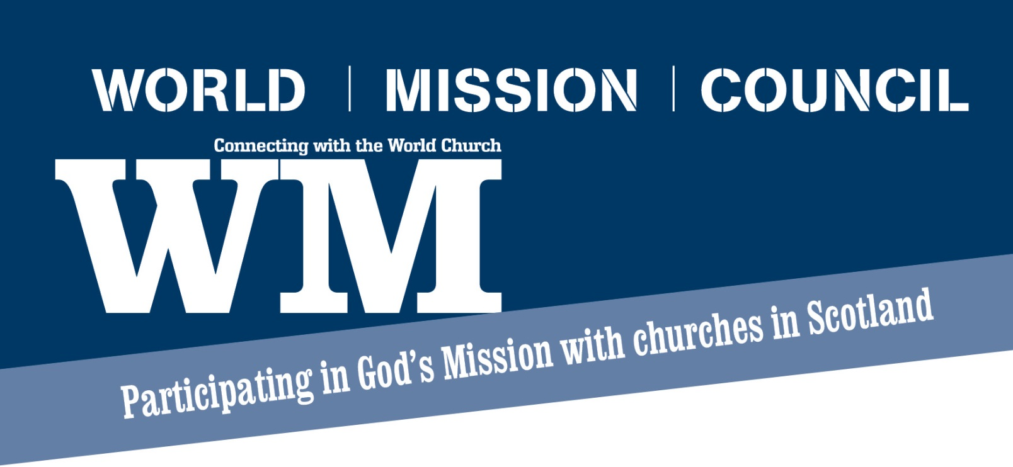**Building a World Church Team**

Building a World Church Team can be a really rewarding experience for a whole congregation.

Decide where it fits into your congregational structure and how you report or get support

* is it a Session Committee?
* is it a Congregational Board committee?
* where does it fit within a Unitary Constitution?

Then identify the various people in your congregation who are responsible for areas where there are connections with the World Church and World Church issues. Bring them together to form the team. It is their role to encourage, engage and enthuse your congregation to become involved in the worldwide work of the Church of Scotland. That work takes many forms and the team members reflect that diversity. The team can be small or large. Ideally it should try to involve people from across your congregation with varying gifts and talents and include people who have specific interest in the World Church. Overleaf a number of suggested roles are detailed. This list is not exhaustive.

You team could:

* bring the world dimension to worship - music, prayer, leading services, Bible study, Youth Church materials.
* communicate regularly with congregation – notice board, magazine, minute for mission etc
* promote the Fairtrade Church initiative – become a Fairtrade Church
* support a Mission Partner
* identify projects to support
* campaign for justice for the world’s poor
* become involved in Christian Aid Week and support them at other times of the year
* develop a twinning with a congregation overseas
* invite and welcome visitors from the world church to your church to share their story
* have a focus on some of the big issues facing our partners overseas eg HIV, climate, Christians in minority situations etc

**For further information contact Karen Gillon, Local Development Officer at** [**kgillon@churchofscotland.org.uk**](mailto:kgillon@churchofscotland.org.uk) **or call 0131 225 5722**



**World Church Representative:**

It would be useful for this lay person to be a member of the Kirk Session. Above all, they should have a personal interest in World Mission. This person is named on the World Mission Council database and will receive mailing items from us and be our primary point of contact with your congregation.

This role involves:

**Informing** - the minister and the congregation of the worldwide work of the Church of Scotland.

**Involving** - a greater interest by the congregation in the life of their fellow Christians beyond their own parish and their own denomination.

**Organising** - activities both with the congregation and with other churches, assisted by other members of the team.

**Liaising** - with their Presbytery's World Mission Convener, the Guild and in particular their project co-ordinator.

**Receiving** - World Mission’s regular magazine WM which provides an insight into the ongoing worldwide work of the Church of Scotland.

**Partner Plan correspondent:**

This role involves:

**Conveying** - the life, work and witness of the congregation to mission partners overseas and the life, work and witness of mission partners to the congregation.

**Writing** - to and encourage others to correspond with the congregation's mission partner.

**Distributing** - copies of the mission partner's letter and ensuring that all members are aware of news contained in it.

**Liaising** - with the World Mission Presbytery Convener about your mission partner's visit during home leave.

**Assisting** - the World Church representative in his/her role in the congregation.

**Receiving** - Partner Plan letters, Partner Plan photographs, biographical notes. Photo displays and PowerPoint presentations are also available for each mission partner works on request.

**Christian Aid representative:**

This role involves:

**Distributing** - Christian Aid materials to the appropriate leaders and organisations in the parish and raising the profile of Christian Aid within the congregation.

**Encouraging** - more church members to receive and read Christian Aid materials.

**Promoting** - action for the issues and concerns that Christian Aid is involved in worldwide.

**Co-ordinating** - your congregation's involvement in Christian Aid week and be their representative on the local Christian Aid committee. You can find out more about Christian Aid week by contacting World Mission or visiting the Christian Aid website [www.christian-aid.org.uk](http://www.christian-aid.org.uk)

**Assisting** - the World Church representative in his/her role in the church.

**Receiving** - Information direct from the Christian Aid office or from the local Christian Aid committee.

**Fairtrade representative:**

This role involves:

Ensuring – the Church has attained Fairtrade status and continues to meet the required criteria.

**Distributing** - Fairtrade materials to the appropriate leaders and organisations in the parish and raising the profile of Fairtrade within the congregation

**Encouraging** - more church members to buy and use Fairtrade materials

**Promoting** - Fairtrade use within the congregation

**Organising** - activities both with the congregation and with other churches, with the assistance of other members of the team that promote the sale and or use of Fairtrade products.

**Assisting** - the World Church representative in his/her role in the church

**Receiving** - Information direct from Fairtrade organisation and ensuring it is used to best effect.

**Youth activity representative:**

It would be useful for this person to either a young person or someone working with the young people of your church. This role involves:

**Encouraging** - young people in your church to engage in the worldwide work of the Church of Scotland.

**Organising** - activities both with the congregation and with other churches, with the assistance of other members of the team that engage, enthuse and educate your young people about the worldwide work of the Church of Scotland.

**Liaising** - with the Youth Church, Boys Brigade, Girls Brigade and any other youth organisations in your congregation to support them in engaging young people in the worldwide work of the Church of Scotland.

**Assisting** - the World Church representative in his/her role in the church.

**Receiving** - Information direct from Fairtrade organisation and ensuring it is used to best effect.