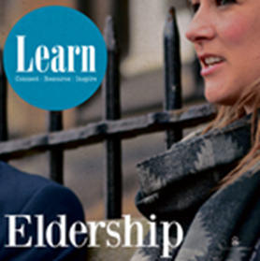
Elder training workshops

Aim
- To discover more about the office of the eldership
- To allow elders to have a deeper appreciation of their role
- To equip elders to carry out the various aspects of their role

Introduction/Opening activity (compulsory) 30 mins

Choice of modules from the following:

- Historical perspective 10 mins
Brief history of the Reformation, links to article on John Knox

- Biblical 25/30 mins
Group exercise based on 4 Bible passages

- Spiritual 30 mins
Includes review of ordination vows, using article on the spiritual
office of the elder

- Relational 30/40 mins
Different pictures of the elder, all of which involve relating to others.
Touches on praying with people

- Structural 15 mins
The elder as charity trustee and the courts of the church

- Strategic 15/20 mins
Different ways of looking at the mission of the church in a changing
Culture; consideration of strengths, weaknesses and goals

- Practical 10/15 mins
Spiritual leadership, public worship, celebration of the sacraments

Timings of the various elements are approximate, depending on questions and discussions.

Other topics e.g. pastoral care, praying with people, listening skills etc can be included as required.

